## Engineer

## What is an engineer?

An engineer is someone who is involved in inventing, designing and maintaining a variety of machines, structures and data systems. Engineers are also responsible for adhering to their employer's specifications for budget and timeline. Engineers are experts in their fields, creating and innovating constantly.



* **Types of Engineering**

1. **Aerospace**

**Engineering**

 Aerospace engineers work to develop things that fly-airplanes, spacecraft, missiles, and so on. They do so by incorporating physics principles such as lift, drag, and thrust. The products that they develop help to defend us from threatening nations and help us go where we need to go, whether that’s a vacation to Greece or a space flight to Mars.

**2. Agriculture & Food Engineering**

 have These engineers are all about food, not unlike myself. Except I just eat it. Food engineers help design systems for producing, storing, and distributing it. They are responsible for ensuring that we can continually produce enough food to feed our growing populations and that the food is stored in a safe and efficient manner. Without them, we would likely to deal with food shortages on a regular basis.

**3. Architectural Engineering**

Architectural engineers are tasked with designing buildings, preferably ones that won’t fall down. To achieve this, they study things like the strengths of various building materials, how to make buildings withstand earthquakes and high winds, how different soil types affect the stability of a building, and so on. Without architectural engineers, we would presumably still be building our homes and community buildings out of mud and sticks. We certainly wouldn’t have the large skyscrapers that we have today.

**4. Automotive Engineering**

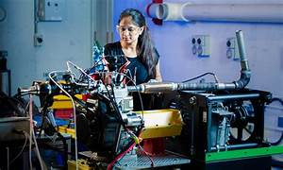 Automotive engineers design the cars, trucks, SUV’s, and vans that you and I drive on a daily basis. They use their knowledge of things like aerodynamics, material densities, and even software and electronics applications to design everything from the physical shapes of cars to their complicated electrical systems. If we didn’t have automotive engineers, getting around would be not only much slower but also much more difficult.

**5. Biomedical Engineering**

medical If you’ve ever been to a hospital, you’ve seen the work of this group. Biomedical engineers are the ones who design the devices and instrumentation used in the healthcare industry. Everything from prosthetic limbs to CPAP machines have been developed by bioengineers. They build the machines and other devices that help save our lives, deliver our babies, and sometimes just live a little more comfortably.

* 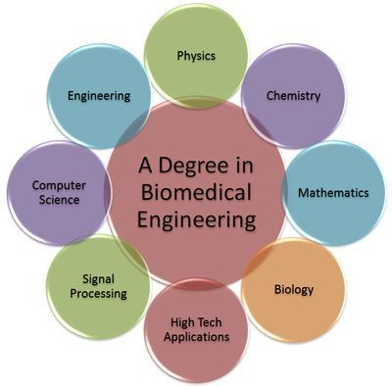

**6. Biotechnology Engineering**

Biotechnology engineers use principles from biochemistry to develop things like medicine, cell and tissue cultures used in research, and even art! Seriously, do a google search for “bio-art” and you can thank me later. Like biomedical engineers, biotechnology engineers study ways to keep us alive and healthy. Without both biomedical engineers and biotechnology engineers, we would likely still have lifespans of only 35 years.



**7. Chemical Engineering**

Chemical engineering is about designing new chemicals for all kinds of uses. They develop plastics and other polymers, fuels, medicines, and many other types of chemical compounds, as well as the processes that are used to make these things from raw materials. Life would definitely be a lot different without chemical engineers.

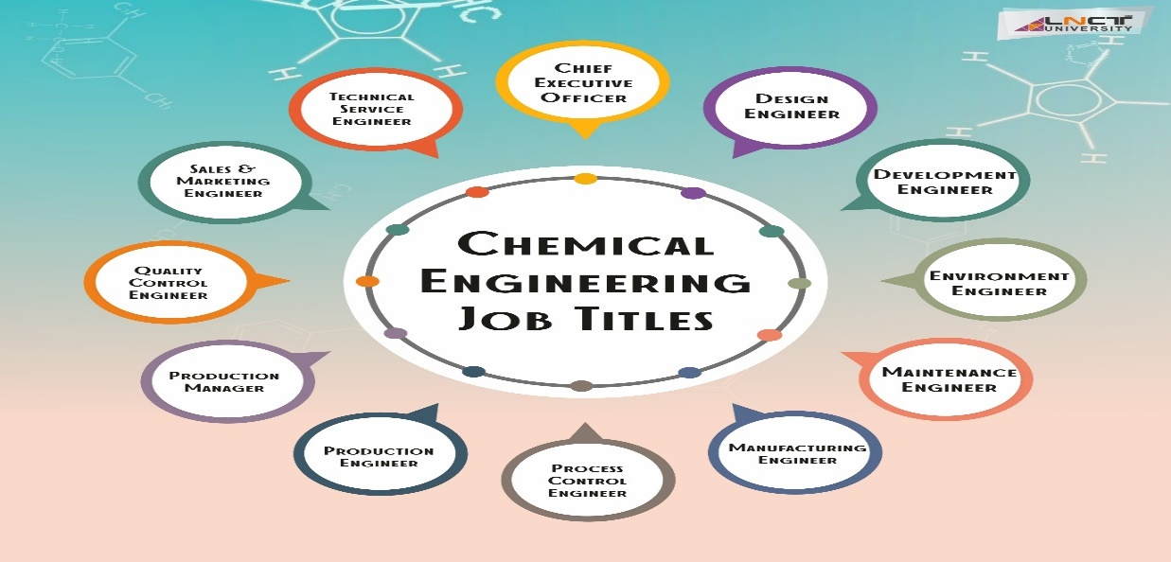**8. Civil Engineering**

The neglected step-children of engineers, civil engineers design some of the most important systems. They design systems to supply people with clean water as well as systems to clean it back up after use. They also design things like roads, bridges, dams, etc. Without civil engineers, we would still be walking through the woods to a nearby river to get water.

**9. Computer Engineering**

Computer engineers don’t only design home computers. They also develop mobile devices, embedded computer systems for industrial processing, computer peripherals like keyboards and printers, machine learning and artificial intelligence programs, and much more. For better or worse, we would never have reached the digital age without computer engineers.

**10. Electrical and Instrumentation Engineering**

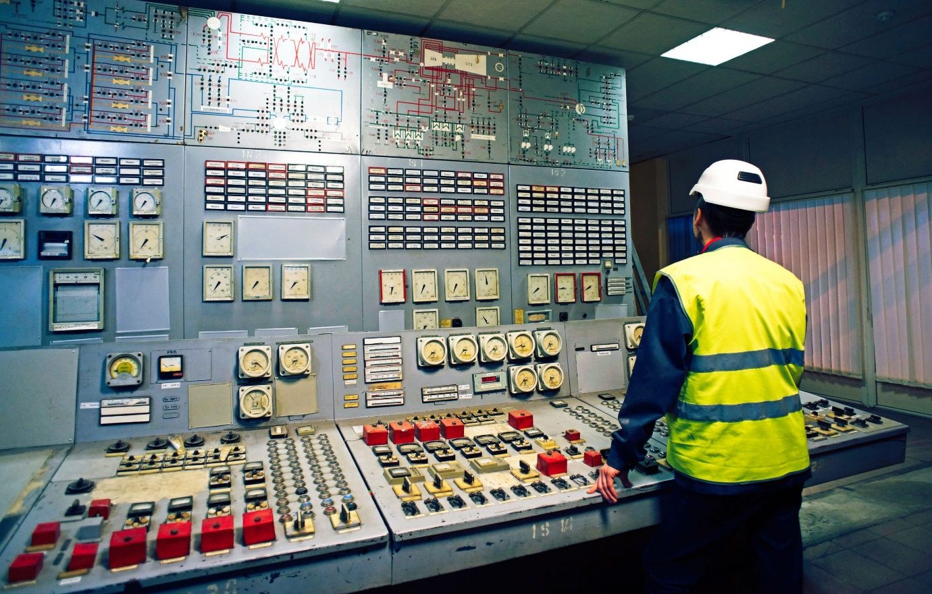Electrical and instrumentation engineers develop machines and equipment that are used in manufacturing, vehicles, research, etc. Most of the other engineers on this list rely in some way on instrumentation that’s designed by an instrumentation engineer. They develop the instruments that help pilots fly and allow doctors and nurses to monitor your vital signs.

**11. Electronics and Communication Engineering**

This is sort of a broader term that includes many of the other types of engineers in this list. Electronics engineers and communication engineers design things like computer systems and telecommunications systems. Electronics engineers design systems that incorporate things like motors and actuators as well as small electronics. Without electronics engineers and communication engineers, we wouldn’t have many of the complicated electronics and control machinery that manufacturers use to produce all of our everyday products.

**12. Environmental Engineering**

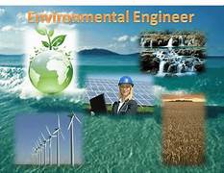As you can imagine, environmental engineers work to solve problems related to the environment, typically problems caused by human activities. They design ways to decrease water and air pollution and chemical runoff from farms and manufacturing facilities. They also tackle issues of public health related to how we interact with our environment. Their biggest challenges involve keeping ecosystems functioning properly despite the continuing growth of human populations. Without environmental engineers protecting wild ecosystems, the organisms that we rely on–the bees that pollinate many of our crops, for example–might not be around.

**13. Industrial and Production Engineering**

Industrial engineers and production engineers develop systems to increase efficiency in industrial and manufacturing facilities. They do this by incorporating things like automation to design new machines and processes that make better use of available resources. Many of the products that we buy would be much more expensive if not for the efficiency in manufacturing that results from the efforts of industrial and production engineers.

**14. Marine Engineering**

What aerospace engineers are to air, marine engineers are to water. They design things that go in the water, including ships, submarines, and even offshore drilling equipment. Many industries that we rely on, from fishing to logistics to defense, require ships and other water vessels to operate. Without marine engineers, we wouldn’t have water skiing or Mediterranean cruises.

**15. Materials Science Engineering**

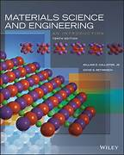These engineers design and develop ways to take raw materials and turn them into materials that we can use to make valuable products. While this is also what chemical engineers do, materials science engineers typically only work with solids to make things like new stronger metals, nonmetals, and more. Many of the materials that the other engineers on this list rely on, like computer chips and plastics and metals for medical devices, wouldn’t exist without materials science engineers.

**16. Mechanical Engineering**

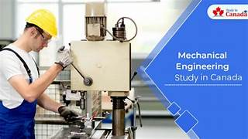Mechanical engineers design many types of machines, such as engines for vehicles and industrial uses, refrigeration systems for restaurants and food storage, turbines for power generation, and more. Without mechanical engineers, we wouldn’t have refrigerators or air conditioning in our homes. Oh yeah, and we also wouldn’t have any electricity to run them even if we did.

**17. Mining and Geological Engineering**

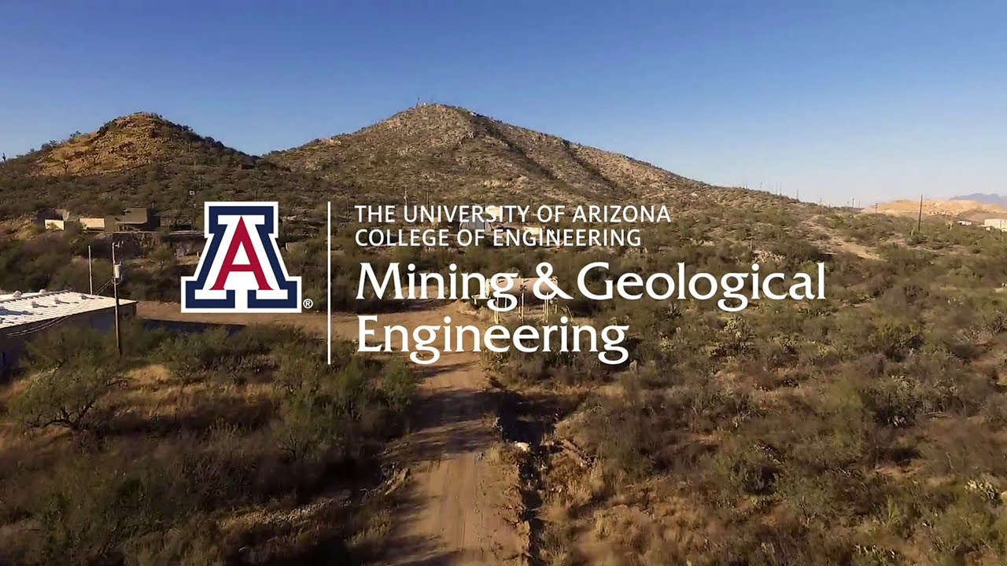Geological engineers study things related to the earth. They can use the knowledge gained from their studies to tell us where to build a tunnel to connect a roadway to two sides of a mountain or how and where to build a hydropower plant. A mining engineer can assist us in safely building a mine for digging up things like coal or gold for energy production or for making electronics and jewelry.

**18. Nuclear Engineering**

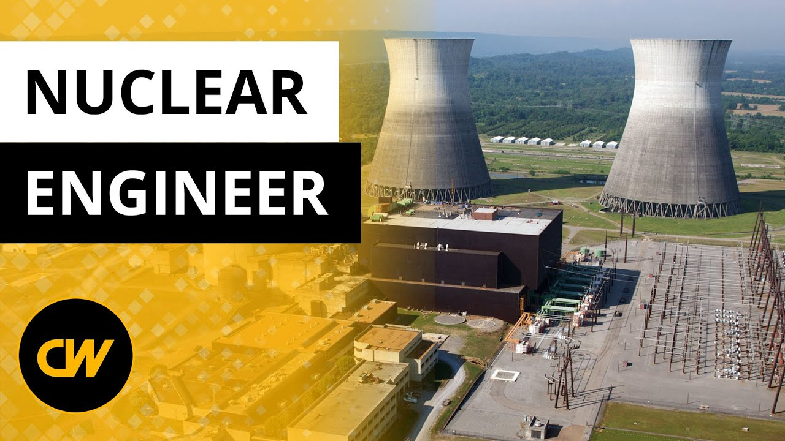Many nations around the world are incorporating nuclear energy into their national energy programs. The nuclear reactors that play a crucial role in producing nuclear energy are designed and built by nuclear engineers. They are tasked with ensuring the reactors are safe, not only for the people who work there but also for the people who live in the surrounding areas.

**19. Petroleum Engineering**

Petroleum engineers not only develop ways of finding oil underground but also methods of extracting it. Since most of our world runs on fuels derived from oil, it’s safe to say that things would be a lot different without petroleum engineers.

**20. Textile Engineering**

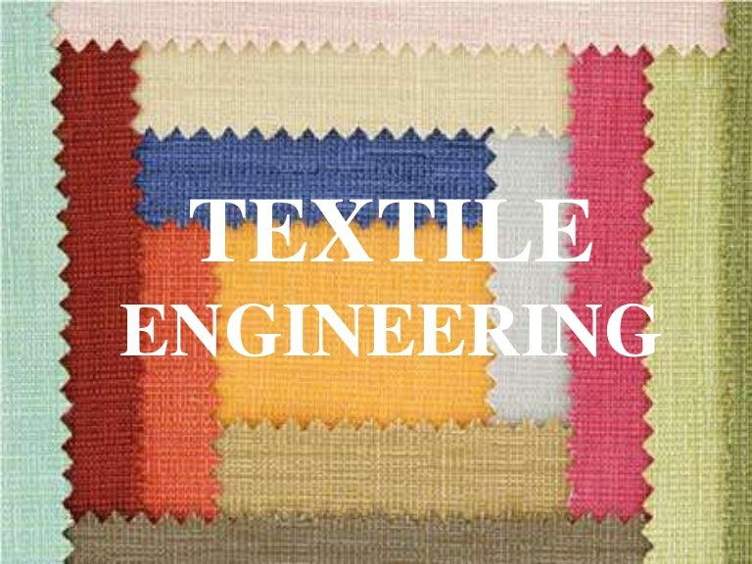Textile engineering involves producing new kinds of fabrics and fibers, not only for making clothing and drapes but also for things like papers and cardboard products. Textile engineers ensure that humanity is not doomed to a life of nothing but cotton and wool socks.

From the products we buy to the homes that we live in, our lives are forever made easier by a group of people we call engineers. And this article is by no means all-inclusive. As new sciences emerge, so do new ways to utilize the fruits of those sciences in ways that can improve our lives. This is the job of an engineer.